**A Project Report on**

**STUDENT INFORMATION MANAGEMENT WEBSITE**

**Submitted in partial fulfillment of requirement**

**For the award of the degree of**

**Diploma Computer Engineering,**

**Gujarat Technological University**

**Submitted by :-**

**r**

***RAJAN S. GAMIT***

***(ENROLL NO: 1234567890)***

***SMITA A TIWARI***

***(ENROLL NO: 4567890321)***

***FALGUN M. ZAVERI***

***(ENROLL NO: 9876543210)***

**Under the guidance of**

Internal Guide HOD

Mr. Nirmit P. Dixit Mr. Arnav Gupta



**Computer Department**

**Government Polytechnic, Bhavnagar**

**October - 2014**

CERTIFICATE

This is to certify that the project entitled

***STUDENT INFORMATION MANAGEMENT WEBSITE***

Submitted in partial fulfillment for the requirement of the degree of

**Diploma Computer Engineering**

Is a result of the bonafide work carried out by

**r**

***RAJAN S. GAMIT***

***(ENROLL NO: 1234567890)***

***SMITA A TIWARI***

***(ENROLL NO: 4567890321)***

***FALGUN M. ZAVERI***

***(ENROLL NO: 9876543210)***

During the academic session July to October 2014. They have undergone the process of shodh yatra, literature survey, problem definition and project designing. They are supposed to carry out the residue UDP Part-II work on same problem during Semester-VI for the final fulfillment of the UDP work.

Internal Guide HOD

Mr. Nirmit P. Dixit Mr. Arnav Gupta



**Computer Department**

**Government Polytechnic, Bhavnagar**

**October - 2014**

ACKNOWLEDGEMENT

We would like to express our sincere thanks and gratitude to Mr. Nirmit P. Dixit , our internal guide for his help, support and guidance throughout this project. This project work would not have been successful without his valuable inputs. He was our source of inspirations during all phases of our project work.

We extend our heartfelt thanks to Mr. Arnav Gupta, Head of Computer Department for his co-operation in our project work.

We cannot forget to express our thanks to the entire staff of our department and colleagues for providing us a helping arm during the project work.

RAJAN S. GAMIT

SMITA A TIWARI

FALGUN M. ZAVERI

ABSTRACT

Student Information Management Website provides a simple interface for maintenance of student information. It can be used by a single department of an educational institutes or colleges to maintain the records of students, faculties and department easily.

Student information website deals with all kind of student details, course details, curriculum, time table, mid-semester exam, notice board and other resource related details too.

It tracks all the details of a student from the day one to the end of the course which can be used for all reporting purpose. Progress in the course, completed semesters, years, curriculum details, mid-exam details, time-table, or any other assignment details will be available through a secure, online interface.

It will also have faculty details, laboratory and classroom details, the various academic notifications to the staff and students updated by the administration. It also facilitate students explore all the activities happening in the department, Different reports and Queries can be generated based on vast options related to students, faculty, exams and semesters.

Index

|  |  |  |  |
| --- | --- | --- | --- |
|  |  |  |  |
| **Chapter 1** | | **Introduction** |  |
|  |  | Project Profile ………………………………………………… |  |
|  |  | Hardware Requirement |  |
|  |  | Software Requirement |  |
|  |  |  |  |
| **Chapter 2** | | **Literature Survey** |  |
|  |  | Existing System |  |
|  |  | Working of current system |  |
|  |  | Shortcomings of current system |  |
|  |  | Existing Site Survey |  |
|  |  | Process Model |  |
|  |  |  |  |
| **Chapter 3** | | **Proposed Website** |  |
|  |  | Introduction |  |
|  |  | Functionalities |  |
|  |  | Advantages |  |
|  |  | System Modules |  |
|  |  |  |  |
| **Chapter 4** | | **System Design** |  |
|  |  | System Flow Diagram |  |
|  |  | Entity Relationship Diagram(ERD) |  |
|  |  | Data Flow Diagram(DFD) |  |
|  |  | Use Case Diagram |  |
|  |  | Data Dictionary |  |
|  |  |  |  |
| **Chapter 5** | | **Conclusion and Future Scope** |  |
|  |  | Limitations of our Project |  |
|  |  | Conclusion |  |
|  |  | Future Scope |  |
| **References and Bibliography** | | | |

Chapter – 1

Introduction

# PROJECT PROFILE

|  |  |
| --- | --- |
| **PROJECT TITLE:** | STUDENT INFORMATION MANAGEMENT WEBSITE |
| **FRONT END:** | PHP Version 5.3.8 |
| **BACK END:** | MY SQL Server version: 5.5.16 |
| **WEB SERVER** | Apache |
| **SUPPORTING TOOLS TO DEVELOP WEBSITE** | HTML 5, CSS 3, JAVASCRIPT |
| **TEXT EDITOR** | Note Pad++ |
| **INTERNAL GUIDE:** | Mr. Nirmit P. Dixit |
| **EXTERNAL GUIDE:** | **------** |
| **PROJECT DURATION:** | 1 YEAR |
| **TEAM SIZE:** | 3 MEMBERS |
| **TEAM NAME:** |  |

# HARDWARE & SOFTWARE REQUIREMENTS

Hardware Requirements:

* Processor: Pentium or Higher version
* RAM: 64 Mb or Higher
* Disk Space: 500 MB (Minimum)

Software Requirements:

* Operating System :- Win-XP /7 or latest version
* Browser : Chrome, Firefox, Internet Explorer etc

Chapter – 2

Literature survey

## Existing system

Some educational institutes may want to use a simple paper-based records keeping system, which is the traditional way of managing student data. In some institutes, they have computerized student data, but still they lack in many ways to synchronize all the information of a department.

## Working of current system

Many members of the department are involved in manual record keeping of the department. All the activities of the department are distributed among the staff members of the department. These activities include student registration, mid-semester exam, time-table, assignments, lab manual etc. The traditional way used to convey information to students is notice-board. Department displays all the information on the notice board. Students note down the information from these notices. But the size of the notice-board is a limitation, so old information have to be taken away to create space for new ones.

During lab hours, faculties give practical to student. If some student is absent or sometimes faculty is absent, it is somewhat difficult to manage the routine teaching.

In case of change of some student’s data, students or college inform the department about it. Department then takes actions to alter the old records.

Staff members have to approach the students to pass any information and student have to physical come to department to get any kind of information.

There are some advantages of manual system as described below:

**Advantages:**

* Less expensive to set up.
* The risk of corrupted data is much less.
* Data loss is less of a risk, particularly if records are stored in a fire-proof environment.
* Problems with duplicate copies of the same records are generally avoided.
* The process is simplified as you don't need to be familiar with computer operation.

**Shortcomings of current system**

There are many drawbacks of this manual system also.

.

1. First, to convey information to the students it should be displayed on the notice board and the student has to visit the notice board to check that information. It takes a very long time to convey the information to the student.
2. Paper records are difficult to manage and track.
3. The physical exertion required to retrieve, alter, and re-file the paper records.
4. Information is scattered.
5. Information can be redundant and it may take long time to collect relevant information.
6. It is almost difficult to back up all information.
7. Some kind of information like faculty information, lab equipment, old notices, etc. is not easily accessible to students.
8. The current system does not provide accurate information. Sometimes due to the mistakes of the employees the data is lost.
9. The process cannot be centralized, so it becomes very time consuming and cumbersome analysis.
10. One of the major drawbacks of the current system is that it does not support online analysis of criticality data.

## Need for the New system

As we have seen in the previous section, there are many drawbacks in the current manual system. So there is a need to develop a website where most of the information of a department can be easily available through a secure interface.

The purpose of a student information management website is to replace the current paper records. Department Staffs are able to directly access all aspects of a student’s academic progress through a secure, online interface embedded in the department’s website.

The main objective of this website is to provide the online interface for students, faculty, Head of the department etc. It increases the efficiency of college record management and decreases time required to access and deliver student records. It also decreases the time spent on non-value added tasks.

## Proposed Website

**INTRODUCTION**

The purpose of a student information management website to replace the current paper records. Department Staff are able to directly access all aspects of a student’s academic progress through a secure, online interface embedded in the department’s website.

The main objective of this website is to provide the online interface for students, faculty, Head of the department etc. It increases the efficiency of college record management and decreases time required to access and deliver student records. It also decreases the time spent on non-value added tasks.

* This project aims at developing a website for student information management. Every department has day-to-day operational issues ranging from the registration to the departure of students. Currently, most of the department’s operations are not integrated and browser-based and hence it takes a lot of effort for creating and maintaining the students’ records, staffs’ records, batch records.

**Functionalities**

The system utilizes user authentication, displaying only information necessary for an individual’s duties. Additionally, each sub-system has authentication allowing authorized users to create or update information in that subsystem.

All data is thoroughly reviewed and validated on the server before actual record alteration occurs. In addition to a staff user interface, the system plans for student user interface, allowing users to access information and submit requests online thus reducing processing time. All data is stored securely on servers managed by the department administrator and ensures highest possible level of security.

The system features a complex logging system to track all users access and ensure conformity to data access guidelines and is expected to increase the efficiency of the department’s record management thereby decreasing the work hours needed to access and deliver student records to users.

Previously, the department relied heavily on paper records for this initiative. This system provides a simple interface for the maintenance of student information. It can be used by educational institutes or colleges to maintain the records of students of a department easily.

Following are main functionalities available on the website:

* Maintains records of Students/Faculties.
* Provides syllabus, study material, assignment, time-table etc
* Conveys various news, events, alerts etc.
* Maintains mid-semester examination
* Etc.

**Advantages**

* This website can be used to manage single department of an educational institute, it is not for the whole college. However, it can be embedded in the existing college website.
* The main objective of the software are storing and managing all the details of students as well as employees, report generation as well as printing and review.
* It is developed with the help of each person who is going to be affected by this system
* This system integrates the existing manual or semi-automated process, starting from candidates/students’ inquiry, registration, mid-semester examination management, faculty management, logistics management and allows the management to compare and creatively analyze the data to enhance the student, faculty and other staff

**System modules**

The Website is for the automation of a single department of a college or an educational institute.

It maintains three levels of users:-

* Administrator Level
* Staff Level
* Student Level

1. **Admin module:**

Administrator is the main person who will manage this whole website.

This module is designed to help the administrator to manage the website efficiently.

Admin can manage all other types of users like student, faculty and it owns all the power to allow or disallow users for using website.

It has the responsibility to verify the data modified by any user before the actual change occurs in the database.

1. **Staff module:**

The staff can update the many information regarding department as well as student. He has power to display information like time-table, syllabus, notice, news, events, mid-sem exam, practical, assignments etc. and any information regarding the subjects they handle. They can also view the student details. The staff also gets the updates from the students and HOD regarding any activity occurring in the department.

1. **Student module:**

Student can access the information of the various departmental activities like syllabus, subject details, faculty details, mid-semester exam, academic calendar etc. He can also get the information of the subject details include the lesson plan, practical list, assignments, information regarding the staff handling the subjects. He can also ask any queries to the staff regarding the subjects. The exam section details include the internal time tables, the room allocation for the exams, it also contains the results. Student can also edit his own profile.

## Existing Site Survey

In the process of developing this website, we have studied following websites. Most of these websites are developed for a college or the university management. We have searched the sites for how they handle a single department of an institute. We have taken many ideas from these sites and we have tried our best to incorporate many of these features in our website so our website can handle a department efficiently.

# Existing Site Survey

There are many websites available for different educational institutes all over world. We have studied following websites and we have tried to take good features from different existing websites and to incorporate in our departmental website. These websites are developed for the whole university or a college. We have studied the departmental information from these websites.

1. [www.ddugu.edu.in](http://www.ddugu.edu.in)

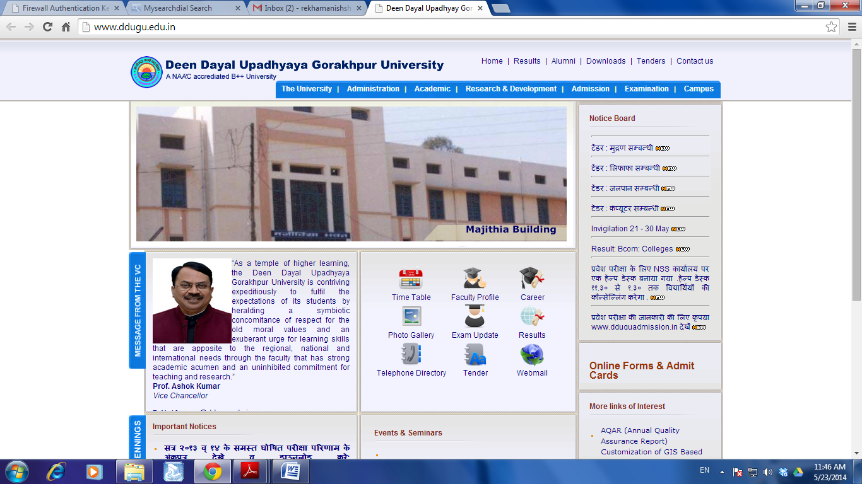

1. <http://www.ddu.ac.in/academics/fot/ce/>

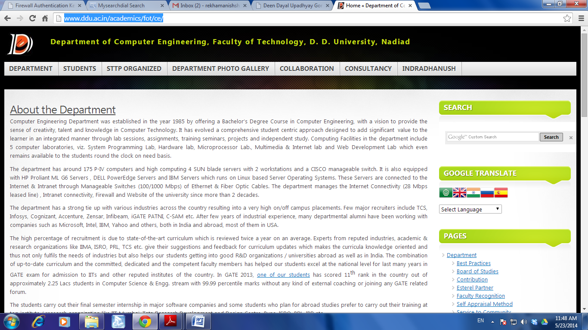

1. [www.nirmauni.ac.in](http://www.nirmauni.ac.in)

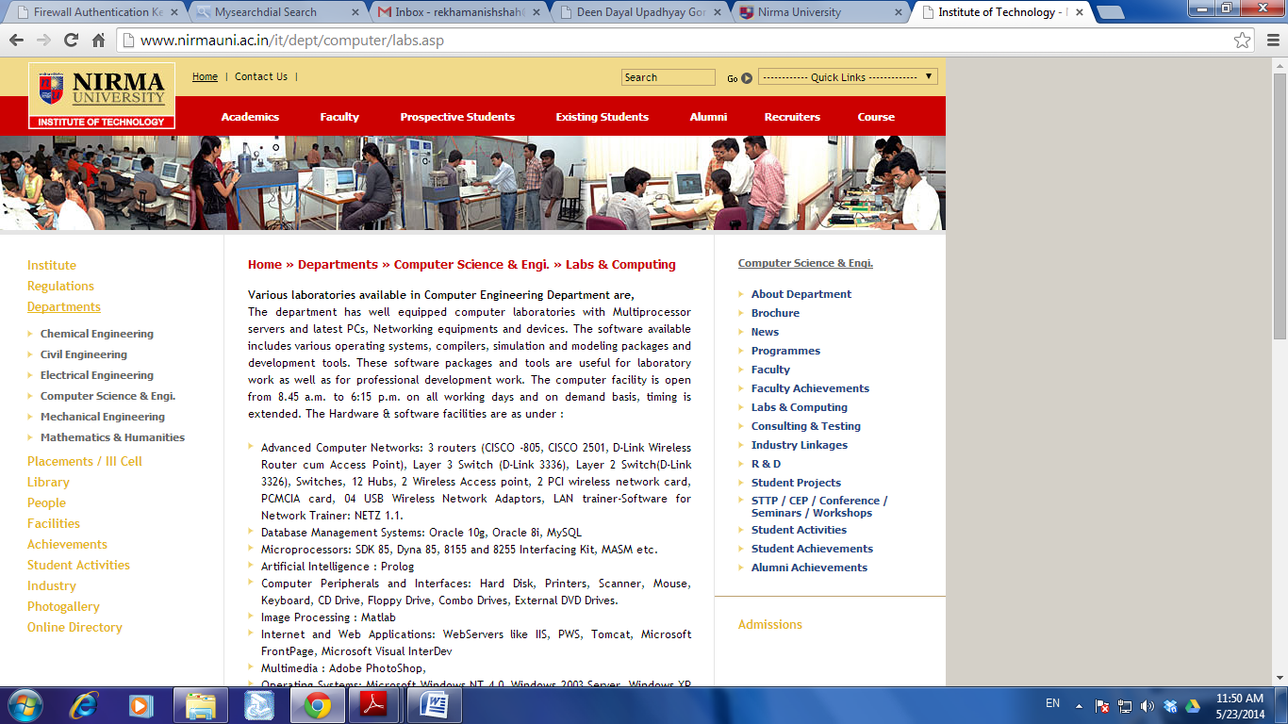

1. [www.pdpu.ac.in](http://www.pdpu.ac.in)

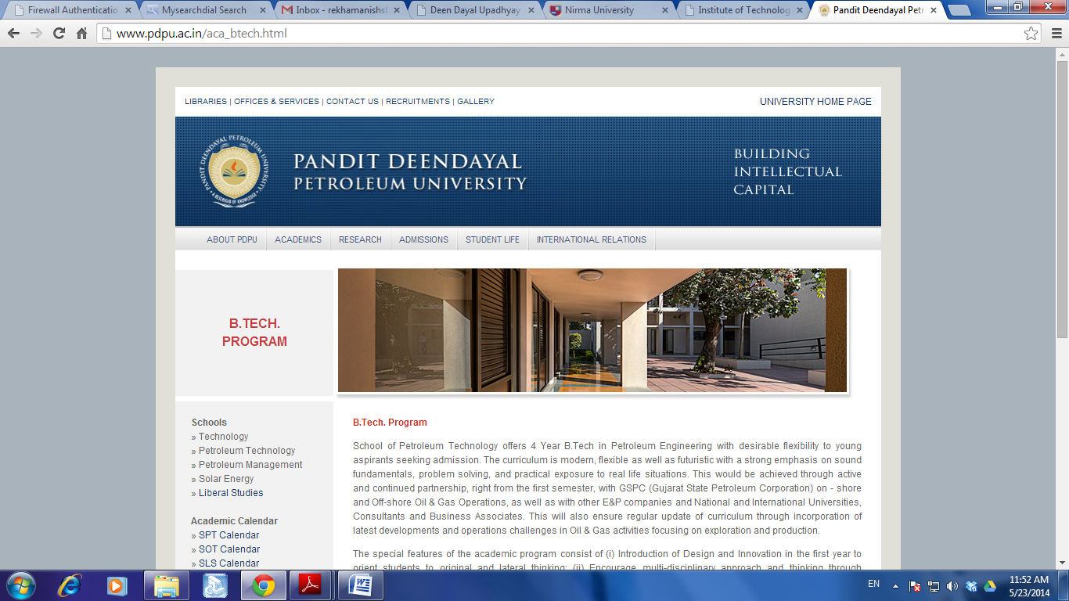

1. [www.svnit.ac.in](http://www.svnit.ac.in)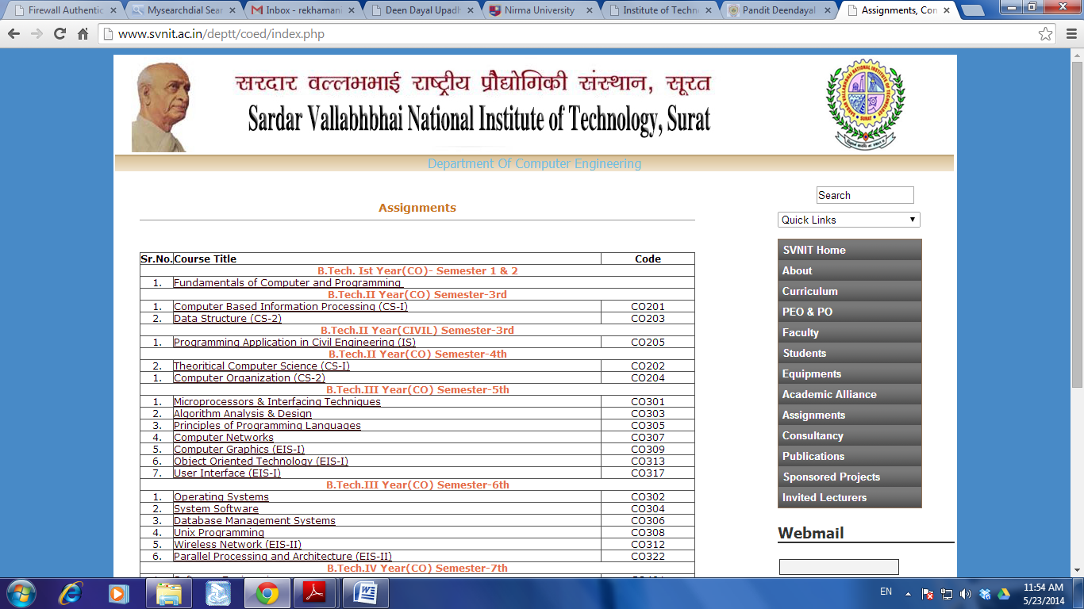
2. [www.iitb.ac.in](http://www.iitb.ac.in)

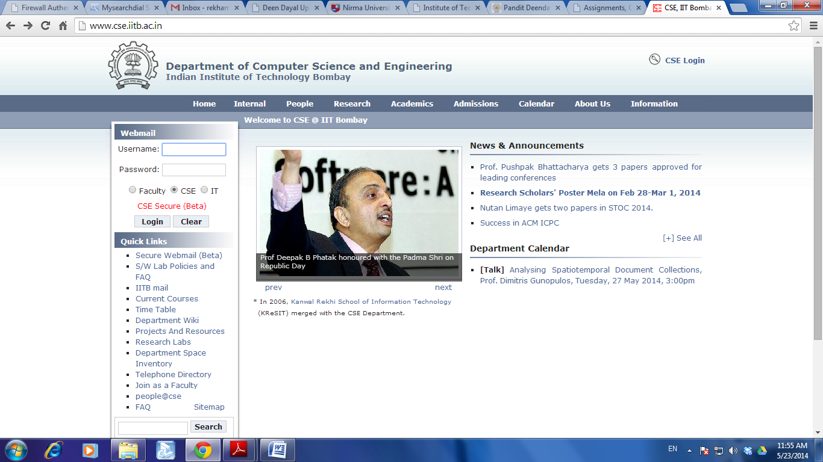

## Process Model

A software development process or life cycle is a structure imposed on the development of a software product. There are several models for such processes, each describing approaches to a variety of tasks or activities that take place during the process. ‘The Waterfall model’ is one of the several models.

Waterfall approach is used widely in Software Engineering to ensure success of the project. In "The Waterfall" approach, the whole process of software development is divided into following separate process phases.

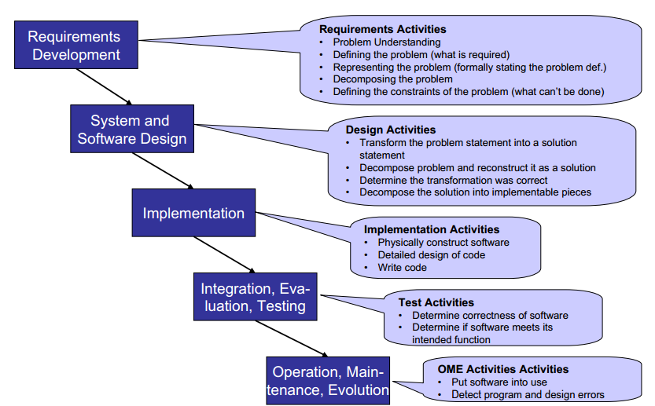

**Benefits of Waterfall Model**

* Simple and easy flow
* Each phase lays out its deliverable, followed by a validation process
* Excellent work progress tracking system
* Best option for smaller projects where business requirements are captured in advance
* Simple and feasible

**Drawback of Waterfall Model**

* The biggest drawback with this model is that once a phase is completed, there is no going back.

As a solution to this problem , another process model ‘ Iterative Water Fall MODEL’ can be used.: -

This model attempts to overcome the limitations of the original model by adding an “iterative” loop to the end of the cycle. That is, in order to keep up with changing requirements the “analysis” phase is revisited at the end of the cycle and the process starts over again.

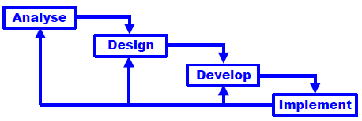

## Web engineering (WebE)

It is usually observed that the existing software engineering models are not having all the features for the systematic development of web based applications.

So, it was needed to adapt the conventional software engineering models to make them

compatible for the development and maintenance of web based applications. To fulfill this need of developing the web based applications in the systematic form, a new approach of web engineering (WebE) comes into play.

WebE deals with the use of sound scientific, engineering and systematic approach to the development, deployment and maintenance of high quality web based systems and applications (WebApps). But, it can be seen that the WebE model can be seen as the adapted version of software engineering model.

## What is a system flowchart?

System flowcharts are a way of displaying how data flows in a system and how decisions are made to control events.

To illustrate this, symbols are used. They are connected together to show what happens to data and where it goes. The basic ones include:

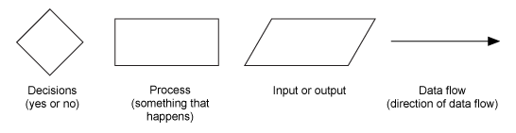

Note that system flow charts are very similar to data flow charts. Data flow charts do not include decisions, they just show the path that data takes, where it is held, processed, and then output.

Following are the system flowcharts of out website:

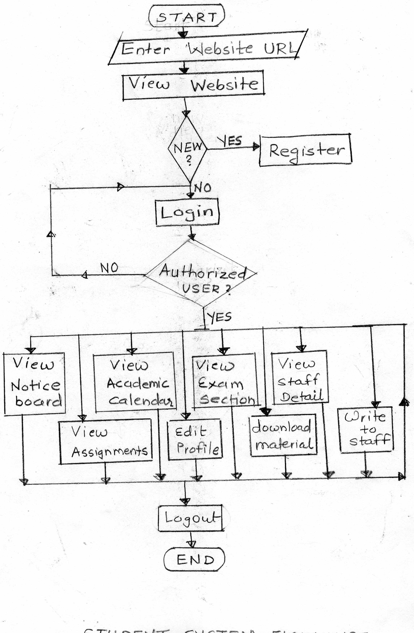**Student System Flowchart**

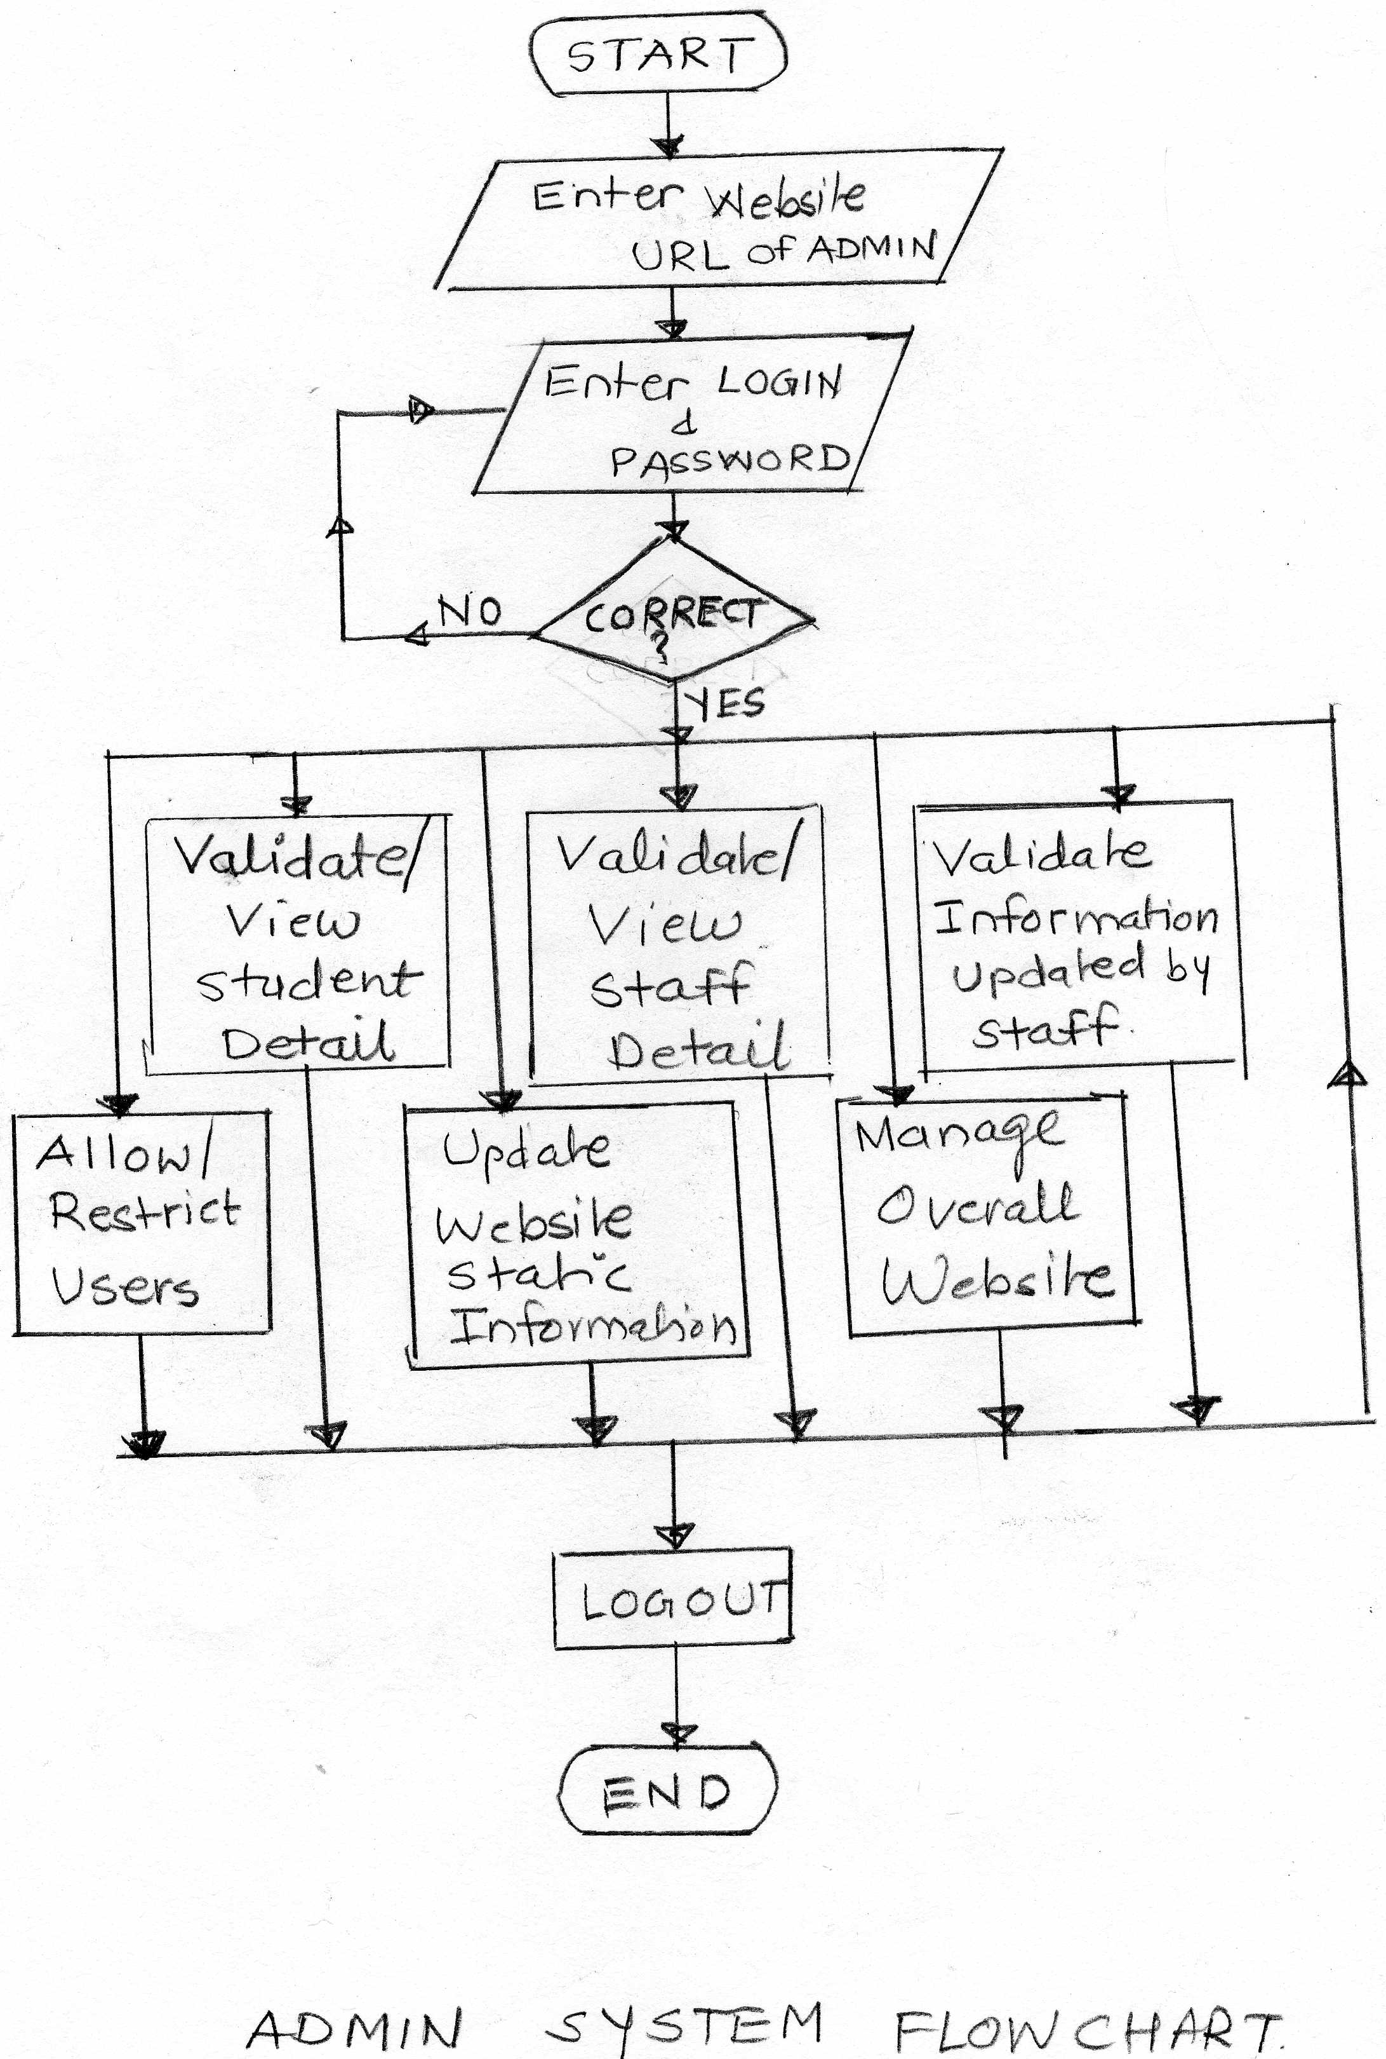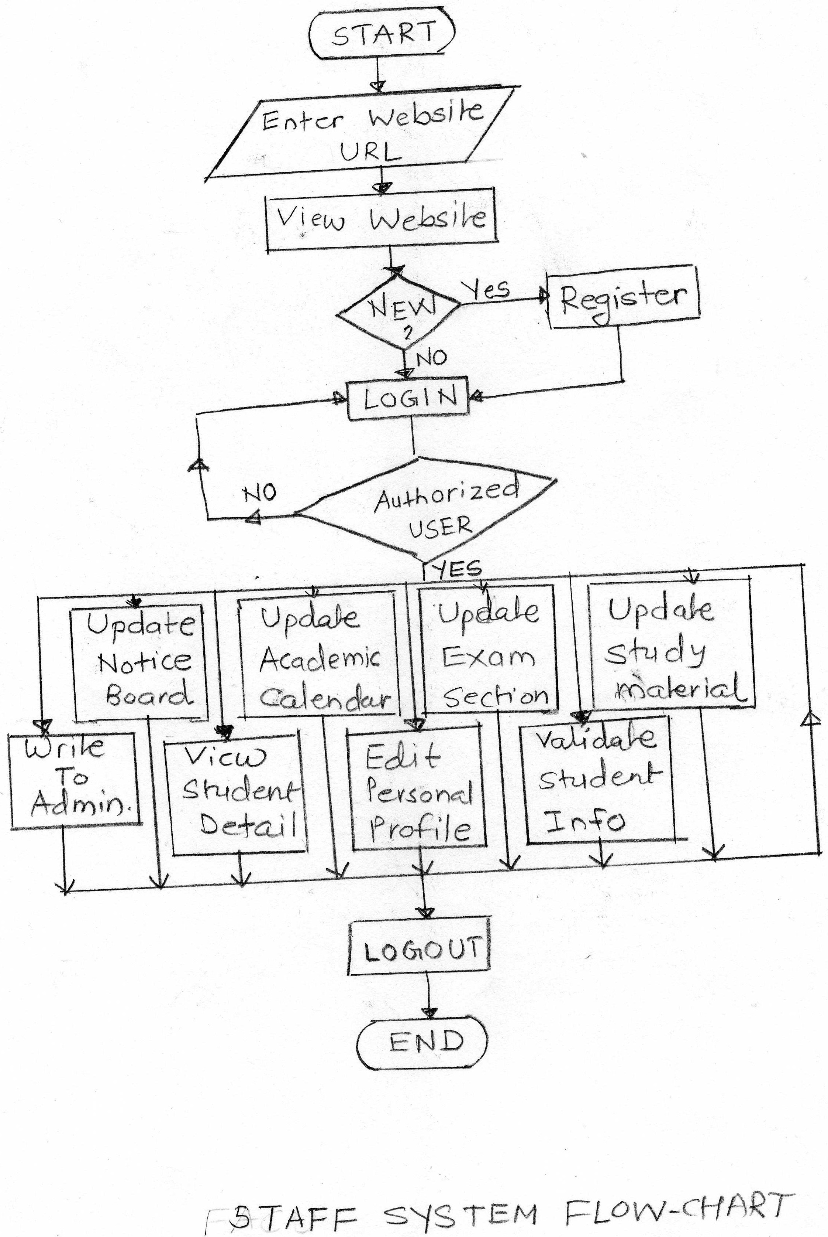

## What is E-R Diagram?

An Entity Relationship Diagram (ERD) is a visual representation of different data using conventions that describe how these data are related to each other.

For example, the elements writer, novel, and consumer may be described using ER diagrams this way:

[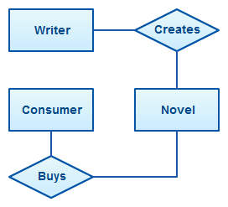](http://creately.com/blog/wp-content/uploads/2012/03/ER-Diagram-Example.jpeg)

*ER diagram with basic objects*

In the diagram, the elements inside rectangles are called **entities** while the items inside diamonds denote the **relationships** between entities.

*ER Diagrams Usage*

ER diagrams are most often associated with complex databases that are used in project. In particular, ER diagrams are frequently used during the design stage of a development process in order to identify different system elements and their relationships with each other.

For example, an inventory software used in a retail shop will have a database that monitors elements such as purchases, item, item type, item source and item price. Rendering this information through an ER diagram would be something like this:

[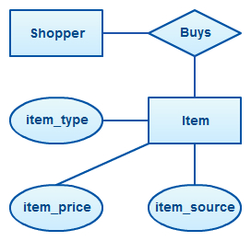](http://creately.com/blog/wp-content/uploads/2012/03/ER-Diagram-Example-2.jpeg)

In the diagram, the information inside the oval shapes are **attributes** of a particular entity.

**ER Diagram Symbols**

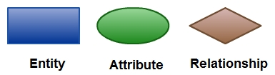

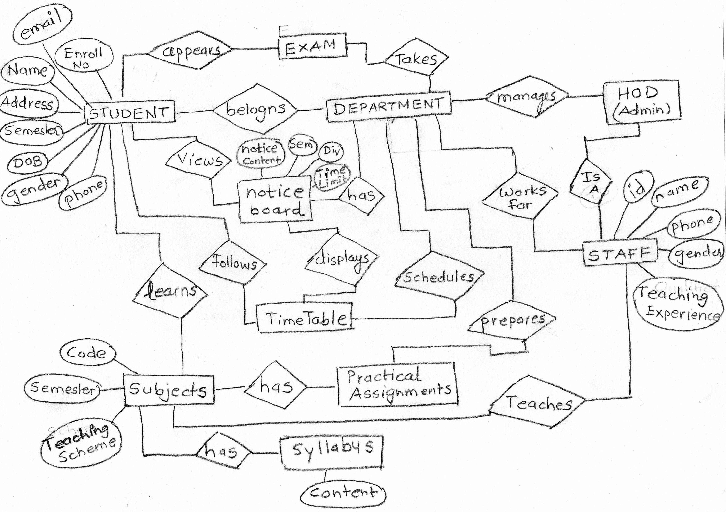

## DFD:

Data flow diagram (DFD) represents the flows of data between different processes in a business.

It is a graphical technique that depicts information flow and the transforms that are applied as data move form input to output.

DFD shows the interaction between the system and outside entities.

Data flow diagrams are commonly used during problem analysis.

**DFD Symbols:**

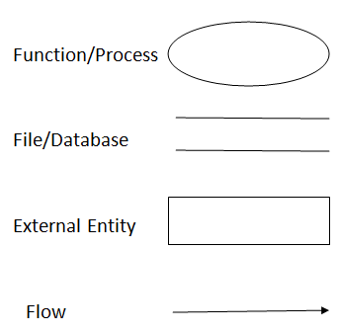

**Rules:**

In order to design a consistent DFD, there are some rules that need to be followed in DFD:

* In Context Diagram, the process could be considered as the project itself.
* In Level 1 of DFD, the processes could be considered as the module(s) in the system.
* In Level 2 of DFD, the processes could be considered as the sub-module(s) of function(s) of the project or module.
* Level 3 or so on, similar to Level 2.

**Context Level / 0 Level DFD**

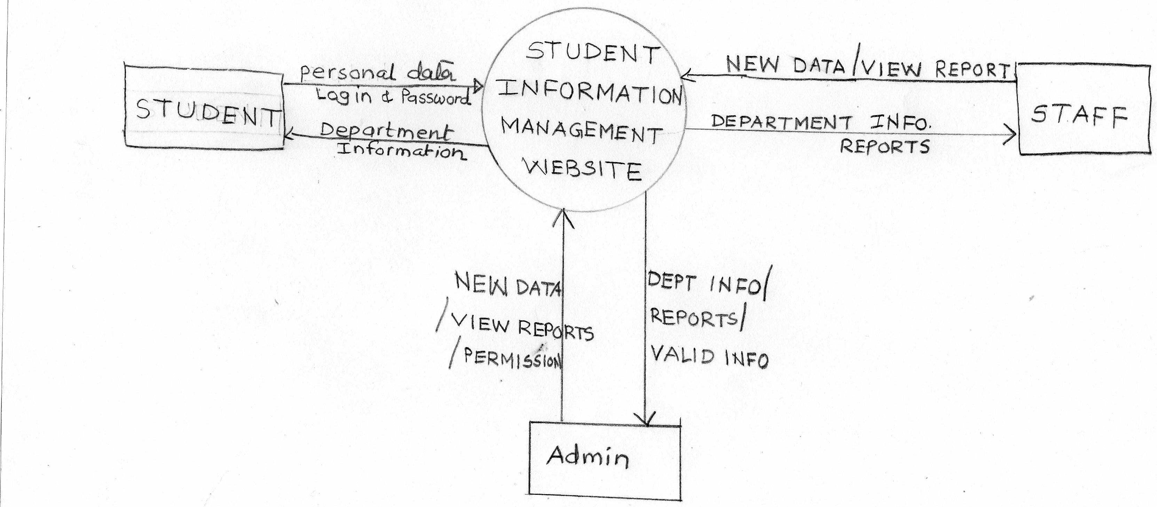

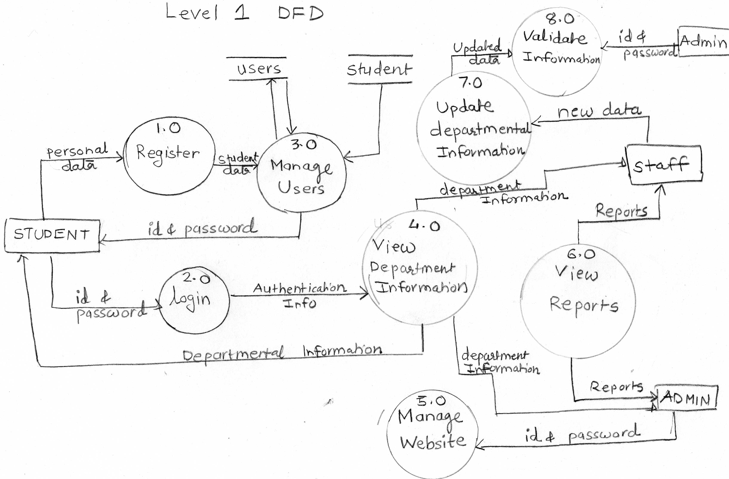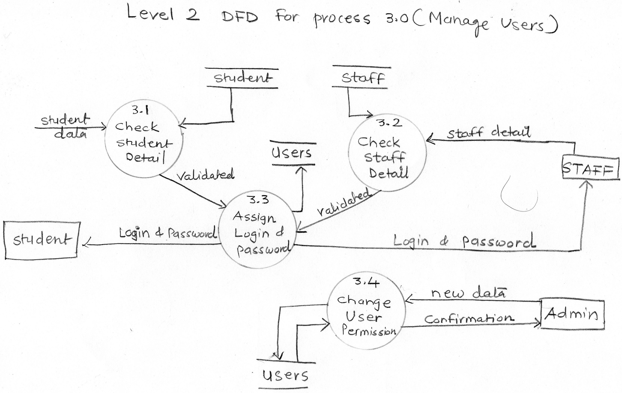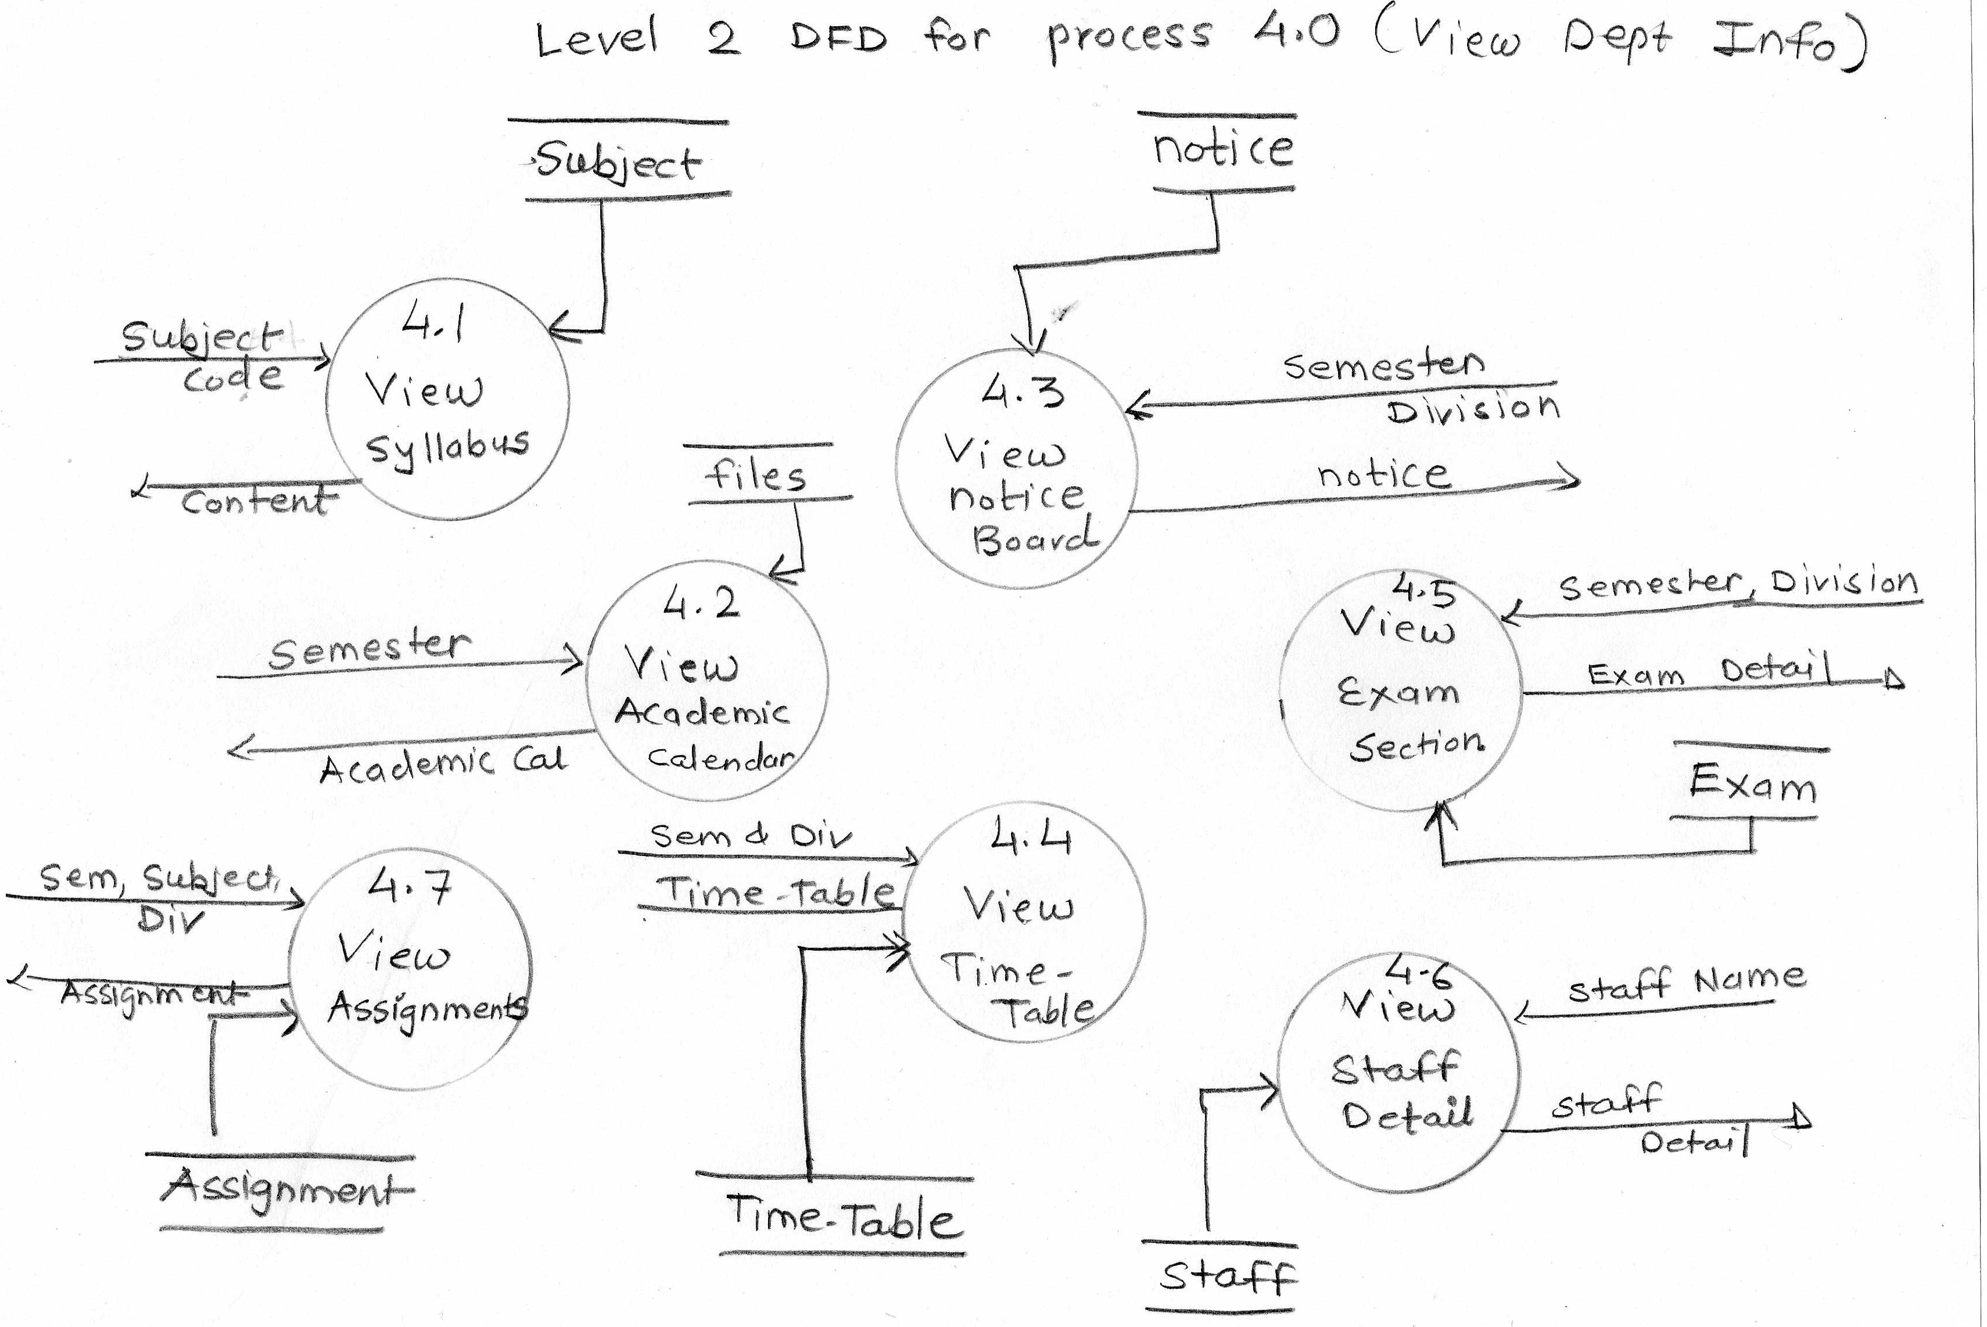

## USECASE DIAGRAM

**What is Use-case diagram?**

 Use case diagram summarizes who uses your application or system, and what they can do with it.

A use case diagram does not show the detail of the use cases: it only summarizes some of the relationships between use cases, actors, and systems.

In particular, the diagram does not show the order in which steps are performed to achieve the goals of each use case.

In a brief when we are planning to draw a use case diagram we should have the following items identified.

* Functionalities to be represented as an use case
* Actors
* Relationships among the use cases and actors.

[**Use-Case Symbols**](http://creately.com/diagram-type/objects/use-case)

[**Actor**](http://creately.com/diagram-type/objects/use-case/actor)



Actor in a **UML Use Case Diagram** is any entity (person, organization or external system) that performs a role in one given system. In a use case diagram, an actor interacts with a use case. For example, in a Student Management System, a student entity represents an actor in the application. Similarly, the Faculty who provides the service is also an actor.

[**Usecase**](http://creately.com/diagram-type/objects/use-case/usecase)



A use case in a **UML Use Case Diagram** gives a visual representation of a distinct business functionalities in a system. For example, for a clinic system, the use cases will be "Make appointment" and "Perform medical tests".

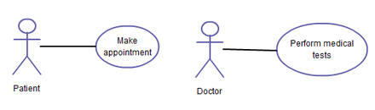

[**System**](http://creately.com/diagram-type/objects/use-case/system)



A system in a **UML Use Case Diagram** is a rectangle spanning all the use cases in the system that defines the scope of your system. Anything within the box represents functionality that is in scope and anything outside is not. Note that the actors in the system are outside the system.

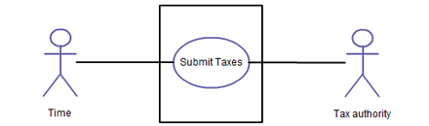

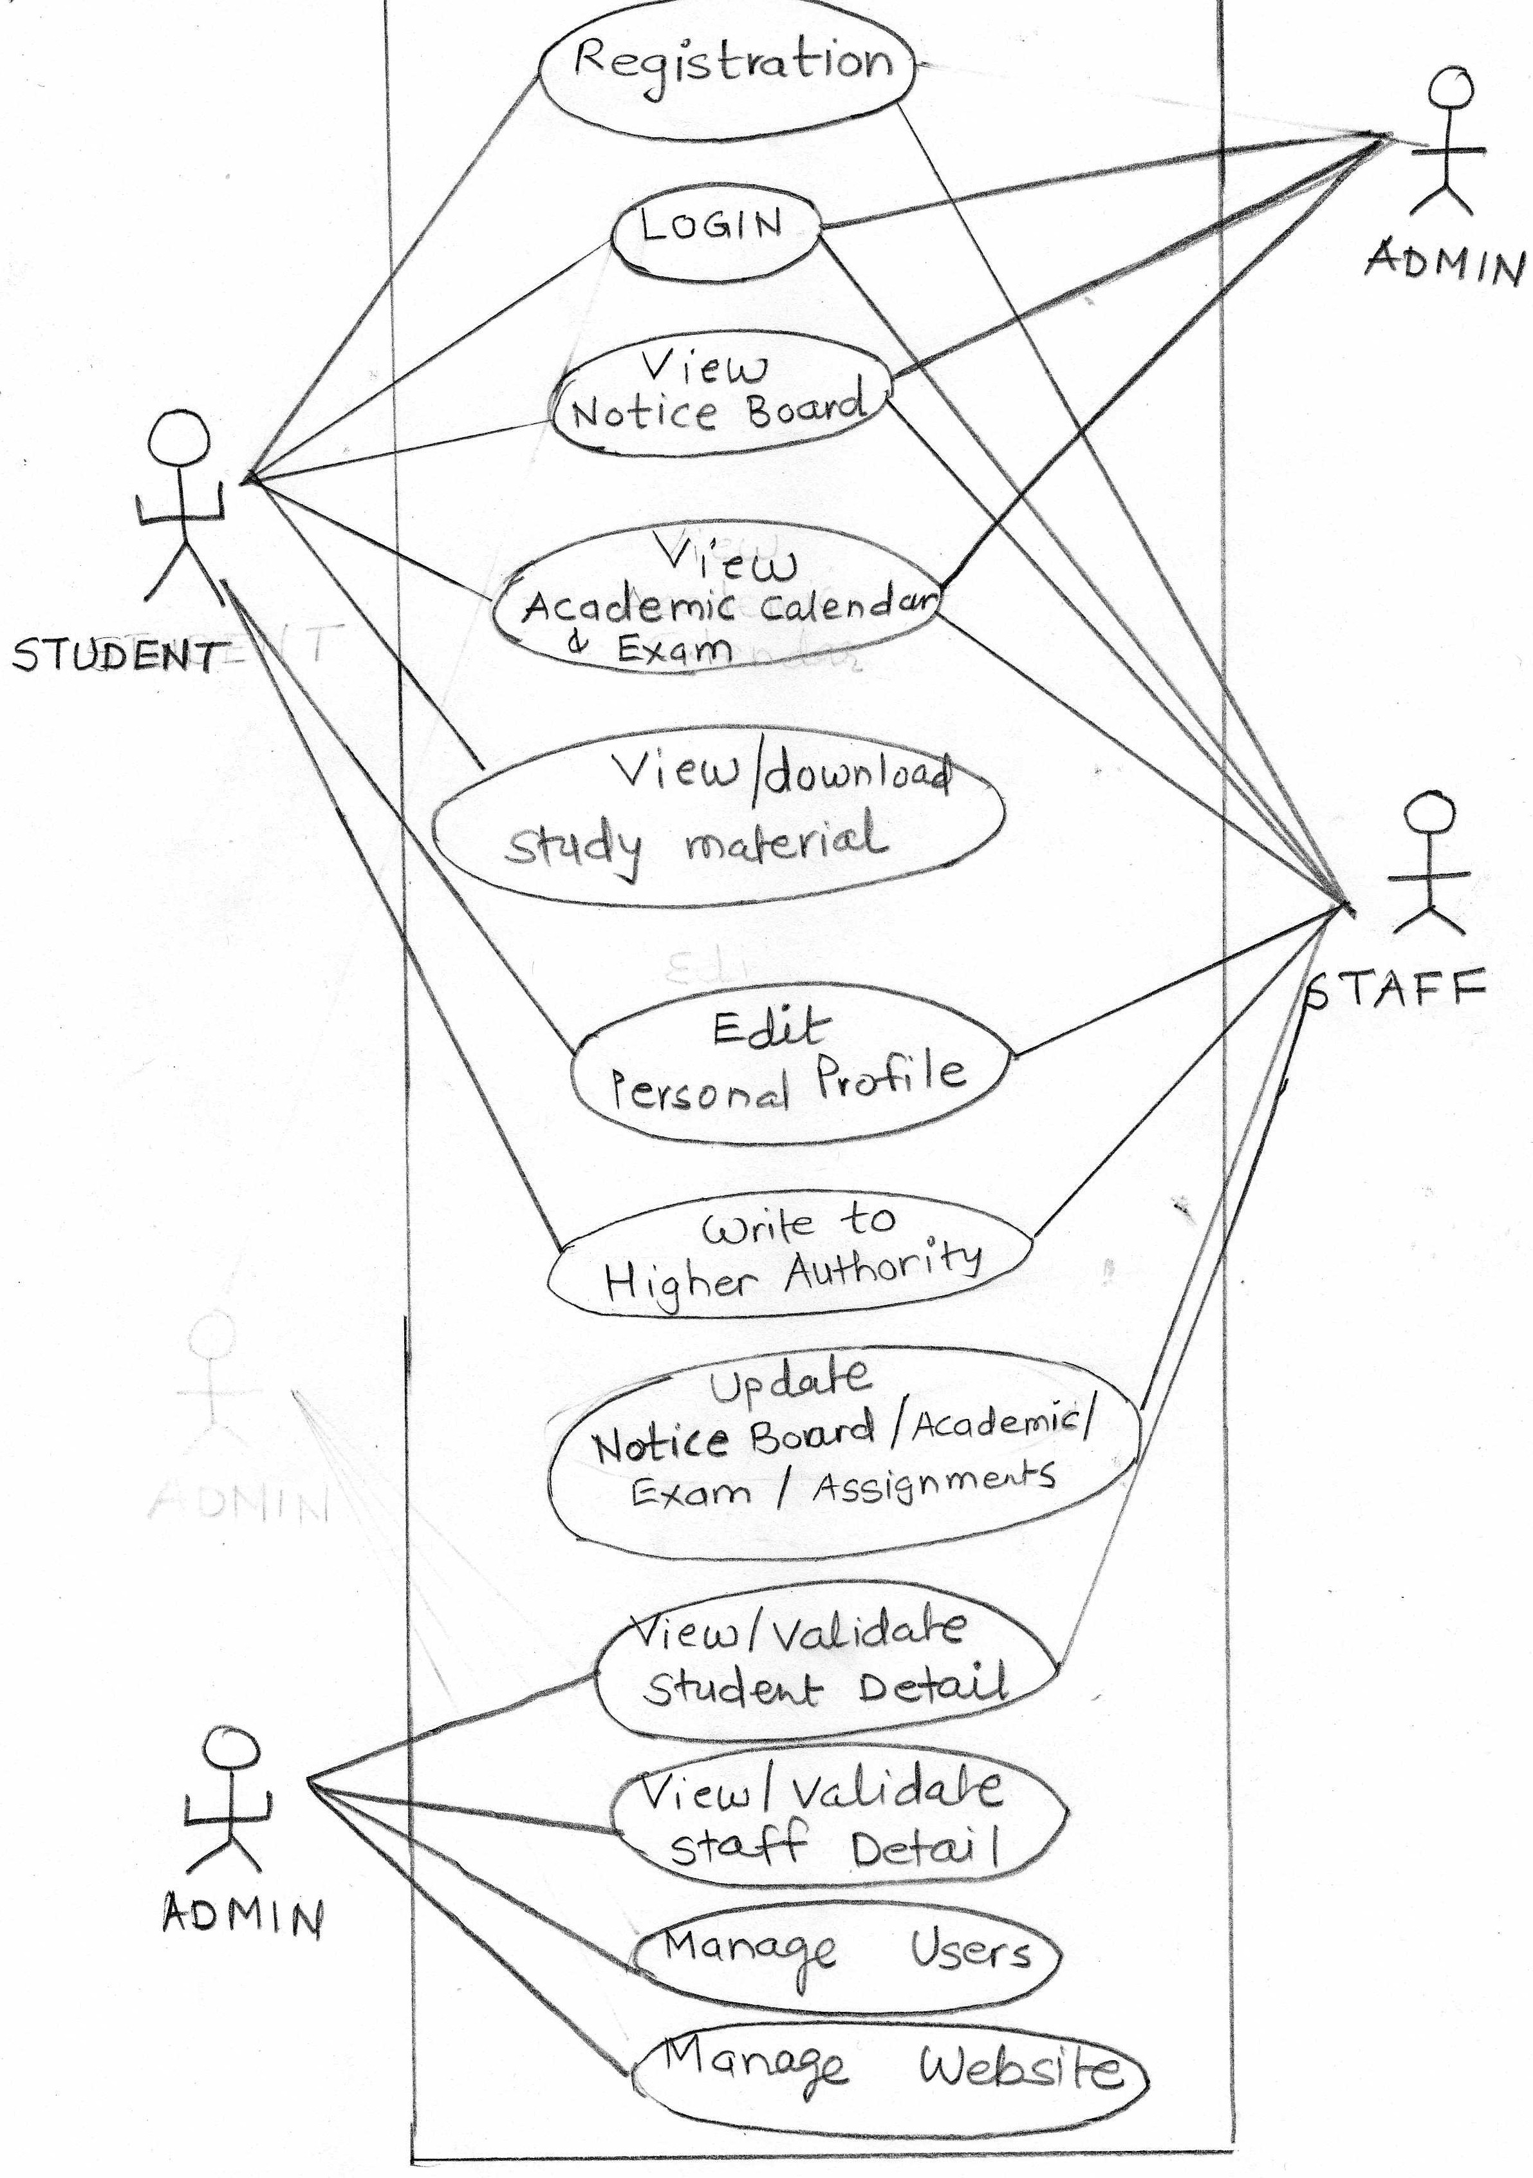

## Data dictionary

Data dictionary describes all the data used in the system. A Data Dictionary is a document that describes the basic organization of a database. Typically a data dictionary will contain a list of variables in the database as well as the assigned variable names and a description of each type of variable (e.g. character, numeric, dates).

The data dictionary should also include the values accepted for each variable, and any helpful comments such as important exclusions and skip patterns. The data dictionary is used primarily for data analysis.

Following table shows tables used in the system.

|  |  |
| --- | --- |
| Table Name | Description |
| STUDENT | Stores the information of students |
| STAFF | Stores the information of staff members |
| USERS | Stores login and passwords of all users of the website |
| SUBJECT | Stores the information of all subjects |
| ASSIGNMENT | Stores the information of assignments of subjects |
| NOTICE | Store all the notices to be displayed on the notice board |
| TIMETABLE | Stores the timetable of all the semesters and all the divisions |
| EXAM | Stores the information regarding mid-semester examination |
| MATERIAL | Stores material of different subjects that students can download |

**Table Name : Student**

**Primary key : EnrollmentNo**

**Foreign key: ----**

**Table details:** This table stores the information of the students.

|  |  |  |  |  |
| --- | --- | --- | --- | --- |
| **Field Name** | **Data Type** | **Constraint** | **Description** | **Example** |
| **EnrollmentNo** | **number(12)** | **Primary Key** | **Enrollment no of the student** | **106340307101** |
| **FirstName** | **string(20)** | **Not null** | **First name of student** | **‘Manan’, ‘Shriya’** |
| **MiddleName** | **string(20)** | **Not null** | **Middle name of student** | **‘Prafulbhai’, ‘Dilipbhai’** |
| **LastName** | **string(20)** | **Not null** | **Last name of Student** | **‘Dixit’, ‘Sharma’** |
| **LocalAddress** | **string(50)** |  | **Local address** | **12, SurSargar Apartmenr, Nr. Limda Chowk, Devipura, Halol-2456.** |
| **PerAddress** | **string(50)** | **Not null** | **Permanent Address** |  |
| **StudentPhone** | **number(10)** |  | **Mobile number of student** | **1234567890** |
| **GardianPhone** | **number(10)** | **Not null** | **Mobile number of Gardian** | **2314567809** |
| **Gender** | **string(1)** | **Not null** | **Gender of Student** | **‘M’ or ‘F’** |
| **BirthDate** | **Date** | **Not null** | **Birth Date** | **01/01/1998** |
| **EmailId** | **string(40)** |  | **Email id** | [**abc@xyz.com**](mailto:abc@xyz.com) |
| **Sem** | **number(1)** | **Not null** | **Current semester in which he is studying** | **5** |
| **Division** | **String(1)** | **Not null** | **Divison of student** | **‘A’,’B’,’C’** |
| **PhotoPath** | **String(50)** | **Not null** | **File name of photo** | **101.png** |

**Table Name : Staff**

**Primary key : Id**

**Foreign key: ----**

**Table details:** This table stores the information of the staff members of the department.

|  |  |  |  |  |
| --- | --- | --- | --- | --- |
| **Field Name** | **Data Type** | **Constraint** | **Description** | **Example** |
| **Id** | **number(2)** | **Primary Key** | **Unique for each staff** | **5,10** |
| **FirstName** | **String(20)** | **Not null** | **First name** | **‘Rajan’, ‘Smita’** |
| **MiddleName** | **String(20)** | **Not null** | **Middle Name** | **‘Pratapbhai’. ‘Kalubhai’** |
| **LastName** | **String(20)** | **Not null** | **Last Name** | **‘Dave’, ‘Mehta’** |
| **LocalAddress** | **String(50)** |  | **Local Address** | **12, SurSargar Apartmenr, Nr. Limda Chowk, Devipura, Halol-2456.** |
| **PerAddress** | **String(50)** | **Not null** | **Permanent Address** |  |
| **Phone** | **Number(10)** | **Not null** | **Mobile number** | **1234567890** |
| **EmailId** | **String(40)** | **Not null** | **Email – id** | [**abc@xyz.com**](mailto:abc@xyz.com) |
| **BirthDate** | **Date** | **Not null** | **Birth date** | **23/05/1985** |
| **Gender** | **String(1)** | **Not null** | **Gender** | **‘M’.’F’** |
| **TeachingExp** | **Number(2)** | **Not null** | **Total teaching experience** | **6** |
| **DateOfJoining** | **Date** | **Not null** | **Date of joining the institute** | **25/03/2009** |
| **Hobbies** | **String(50)** |  | **Hobbies** | **Sports, reading, outing** |
| **PhotoPath** | **String(50)** | **Not null** | **File name of photo** | **Rajan.png** |
| **Sem** | **Number(1)** |  | **staff is in-charge of this semester** | **2** |
| **Division** | **String(1)** |  | **staff is in-charge of this division** | **‘A’** |
| **ExpertSubjects** | **String(50)** |  | **List of subject in which staff is expert** | **PHP, vb.net, SQL, ADO.Net** |

**Table Name : Users**

**Primary key : Login**

**Foreign key: ----**

**Table details:** This table stores the information of the users of the website.

|  |  |  |  |  |
| --- | --- | --- | --- | --- |
| **Field Name** | **Data Type** | **Constraint** | **Description** | **Example** |
| **Login** | **String(30)** | **Primary Key** | **Unique login name of each user** |  |
| **Password** | **String(60)** | **Not null** | **Encrypted password** |  |
| **UserType** | **String(1)** | **Not null** | **For staff, it will store ‘F’, for student – ‘S’, admin – ‘A’** | **‘A’. ‘F’, ‘S’** |
| **Id** | **Number(12)** | **Foreign Key** | **Enrollment number of student or id of staff** | **4, 106340307101** |
| **Active** | **Boolean** | **Not null** | **If the student or staff leaves, it will be not active. Admin can also make the user inactive. ‘Y’ means active** | **‘Y’, ‘N’** |

**Table Name : Subject**

**Primary key : Code**

**Foreign key: ----**

**Table details:** This table stores the information of the subjects of all semesters.

|  |  |  |  |  |
| --- | --- | --- | --- | --- |
| **Field Name** | **Data Type** | **Constraint** | **Description** | **Example** |
| **Code** | **String(10)** | **Primary Key** | **Subject code** | **2340701** |
| **Name** | **String(50)** | **Not Null** | **Subject Name** | **‘Computer Network’** |
| **Sem** | **Number(1)** | **Not Null** | **Semester in which this subject is offered** | **4** |
| **Date** | **Date** | **Not Null** | **Date from which this subject introduced** | **12/01/2012** |
| **TheoryHrs** | **Number(1)** |  | **Total theory hours per week** | **3** |
| **PracitcalHrs** | **Number(1)** |  | **Total practical hours per week** | **4** |
| **TutotialHrs** | **Number(1)** |  | **Total tutorial hours per week** | **0** |
| **Theory** | **boolean** | **Not Null** | **Whether this subject contains theory or only practical subject. ‘N’ means only practical, no theory** | **‘Y’** |
| **SyllabusFile** | **String(50)** | **Not Null** | **Syllabus file name** | **CN.pdf** |

**Table Name : Assignment**

**Primary key : Id**

**Foreign key: ----**

**Table details:** This table stores the assignments given for different subjects.

|  |  |  |  |  |
| --- | --- | --- | --- | --- |
| **Field Name** | **Data Type** | **Constraint** | **Description** | **Example** |
| **Id** | **Number(6)** | **Primary key** | **Unique number for each record** | **4** |
| **SubjectCode** | **Number(10)** | **Foreign key** | **Code of subject for which this assignment belongs** | **120876** |
| **StaffId** | **Number(2)** | **Foreign key** | **Id of staff who has prepared this material** | **12** |
| **Division** | **String(1)** |  | **Division of semester for which this assignment is given.** | **‘B’** |
| **Date** | **Date** | **Not null** | **Date on which this assignment is given** | **02/09/2014** |
| **AssignmentFile** | **String(50)** | **Not null** | **Name of file that stores this assignment content** | **CNass2.pdf** |

**Note: If the division is null, the assignment is for all the divisions of that semester.**

**Table Name : Notice**

**Primary key : Id**

**Foreign key: ----**

**Table details:** This table stores the notices for all the students to be displayed on the notice-board.

|  |  |  |  |  |
| --- | --- | --- | --- | --- |
| **Field Name** | **Data Type** | **Constraint** | **Description** | **Example** |
| **Id** | **Number(5)** | **Primary key** | **Unique number for each record** | **4** |
| **Sem** | **Number(1)** |  | **Semester for which this notice is issued** | **3,5,4** |
| **Division** | **string(1)** |  | **Division for which this notice is issued.** | **‘C’, ‘A’** |
| **Date** | **Date** | **Not null** | **Date on which notice is issued** | **03/07/2014** |
| **Urgent** | **Boolean** |  | **Whether notice is urgent? ‘Y’ means urgent.** | **‘Y’, ‘N’** |
| **NoticeFile** | **String(50)** | **Not null** | **Name of file which stores the notice content** | **Notice2.pdf** |

**Note:**

* **If Sem and division both are null, then notice will be shown to all semester, all division students.**
* **If division is null and semester value is given (e.g. sem-2) then notice will be for all the divisions of that semester.**

**Table Name : TimeTable**

**Primary key : Id**

**Foreign key: ----**

**Table details:** This table stores the information of the time-table.

|  |  |  |  |  |
| --- | --- | --- | --- | --- |
| **Field Name** | **Data Type** | **Constraint** | **Description** | **Example** |
| **Id** | **number(5)** | **Primary key** | **Unique number for each record** | **4** |
| **Sem** | **number(1)** | **Not null** | **Semester** | **5** |
| **Division** | **string(1)** | **Not null** | **Division** | **‘A’** |
| **Date** | **date** | **Not null** | **Date from which this TimeTable is effective** | **03/11/2013** |
| **TimetableFile** | **string(50)** | **Not null** | **Name of file that stores the timetable** | **TT2.pdf** |

**Table Name : Material**

**Primary key : Id**

**Foreign key: ----**

**Table details:** This table stores the information of the material of different subjects.

|  |  |  |  |  |
| --- | --- | --- | --- | --- |
| **Field Name** | **Data Type** | **Constraint** | **Description** | **Example** |
| **Id** | **Number(5)** | **Primary Key** | **Unique number for each record** | **2,5,100** |
| **SubjectCode** | **number(10)** | **Foreign Key** | **Subject code** | **3350920** |
| **StaffId** | **Number(2)** | **Foreign key** | **Id of staff who has prepared this material** | **11** |
| **Date** | **Date** |  | **Date on which material is kept on website** | **12/04/2014** |
| **MaterialFile** | **string(50)** | **Not null** | **File name that stores content** | **Java.pdf** |

**Table Name : MidExam**

**Primary key : Id**

**Foreign key: ----**

**Table details:** This table stores the information of the mid-semester examinations.

|  |  |  |  |  |
| --- | --- | --- | --- | --- |
| **Field Name** | **Data Type** | **Constraint** | **Description** | **Example** |
| **Id** | **Number(5)** | **Primary Key** | **Unique number for each record** | **2,5,100** |
| **Subjectcode** | **number(10)** | **Foreign Key** | **Subject code** | **3350920** |
| **Division** | **string(1)** | **Not null** | **Division** | **‘A’, ‘B’, ‘C’** |
| **ExamDate** | **Date** | **Not null** | **Examination date** | **20/09/2014** |
| **TimeTo** | **date-time** | **Not null** | **Start time of exam** | **14:00** |
| **TimeFrom** | **date-time** | **Not null** | **End time of exam** | **16:00** |
| **ClassRoom** | **number(3)** | **Not null** | **Class room number** | **12, 201** |
| **MidRemid** | **boolean** | **Not null** | **For mid exam , it stores ‘Y’ and for remid exam it stores ‘N’** | **‘Y’,’N’** |
| **SyllabusFile** | **string(50)** | **Not null** | **File name that stores the syllabus of this subject** | **Php.pdf** |

## Limitations

* The proposed system is developed to overcome the shortcomings of the manual system, but still there are many limitations to this new system.
* The limitations are as follows:
* This website is developed for a single department. At the starting of each semester, everyone has to register in this website though they have registered previously.
* It doesn’t have the features like attendance, result, assignment submission etc.
* Many features can be made more dynamic.

## Future Scope

* Software development is ever changing process. Website is also a kind of software , so it always prone to changes.
* There is always a chance of improvement as technology evolves.
* As we discussed in the limitations section, we can upgrade the website to incorporate those changes.
* We can make the website more dynamic and we can also extend it to manage more than one department.

## Conclusion

* At the time submitting the report we have successfully designed the website to handle a department of an educational institute.
* We have also designed our data dictionary to store most the data but when we will implement the system in the next semester, it may be possible that data dictionary may change,
* We have tried our best to make our website user friendly and useful to manage a department.

## **BIBLIOGRAPHY**

Web Reference (website names)

1. <http://www.google.com>
2. <http://www.W3schools.com>

4.

5.

6.

Books